Jahangirnagar University

Department of Computer Science & Engineering



Course Code: CSE-402

Course Title: Computer Networking Laboratory

Submitted by :

Name : Shamim Imtiaz

Roll No. : 47

Date of Submission : 29th August, 2019

**Experiment no.** : 01

**Experiment Name :** Fundamentals of Computer Network

1. **“tracert” command :**

The “tracert” command is a Command Prompt command that's used to show several details about the path that a packet takes from the computer or device we’re on to whatever destination is specified.

Here the destination is “[www.google.com](http://www.google.com)”

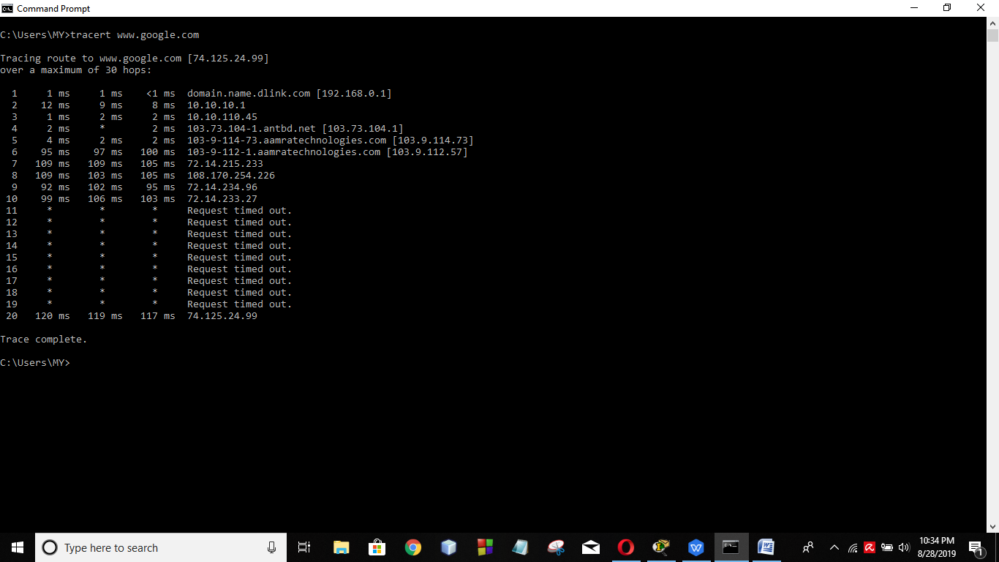

This screenshot shows the IP addresses of the gateways that the packet faced to go to the destination address and the time taken.

1. **“ipconfig” command:**

“ipconfig” command displays all current TCP/IP network configuration values and refreshes Dynamic Host Configuration Protocol (DHCP) and Domain Name System (DNS) settings. Used without parameters, ipconfig displays the IP address, subnet mask, and default gateway for all adapters.

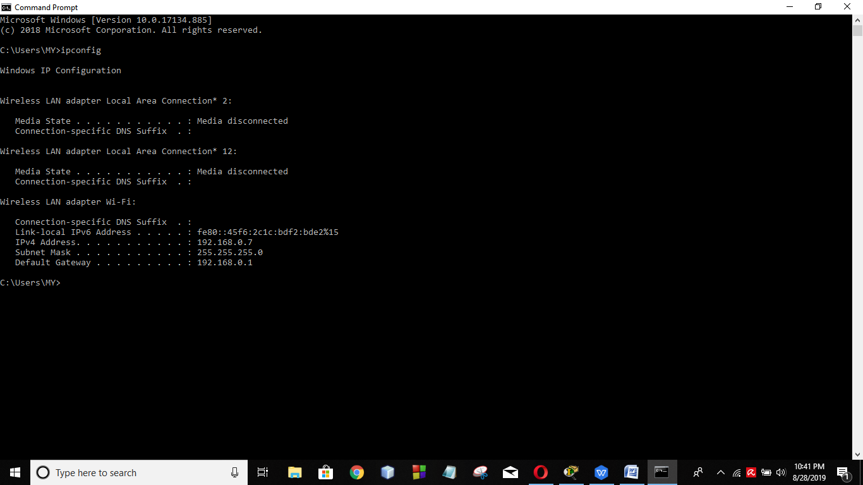

This sceenshot shows the windows IP configuration.

1. **“ping” command :**

The ping command sends packets of data to a specific IP address on a network, and then let us know how long it took to transmit that data and get a response.

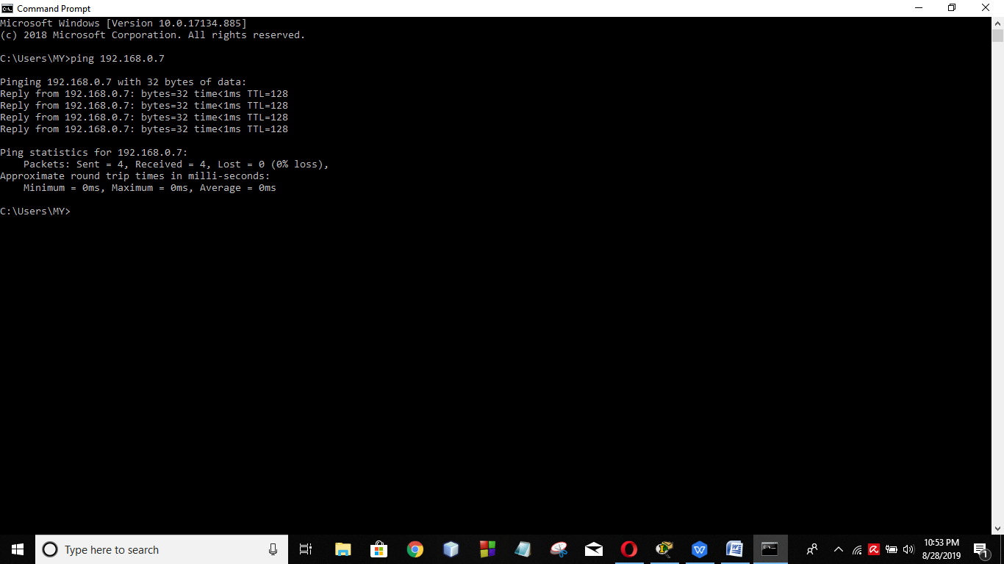

Here the screenshot shows the result of “ping 192.168.0.7” command.

1. **“ping –t” command :**

“ping -t” command sends packets continuously.

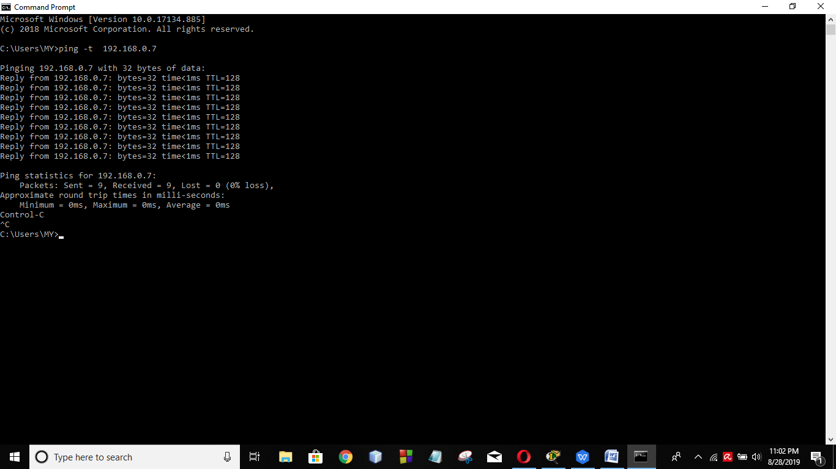

1. **Show the operation of a hub using tracer simulation.**

This screenshot shows the transmission of data between 4 devices using a hub. A hub is a common connection point for devices in a network. Hubs are commonly used to connect segments of a LAN. A hub contains multiple ports. When a packet arrives at one port, it is copied to the other ports so that all segments of the LAN can see all packets.

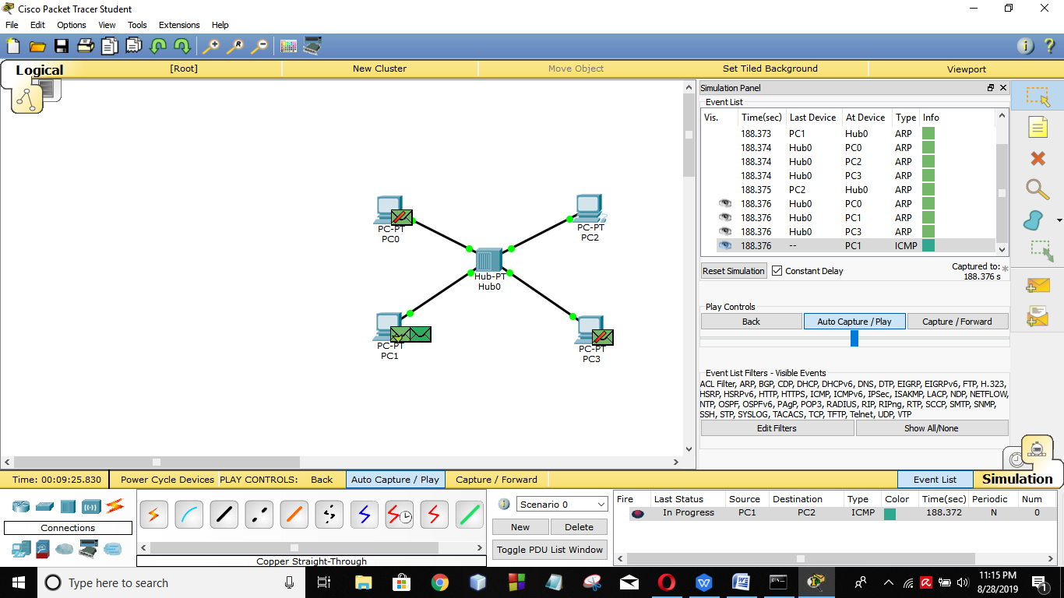

1. **Show the operation of a hub & a switch using tracer simulation.**

This screenshot shows the transmission of data between 8 devices using a hub & a switch. A switch is used in a wired network to connect to other devices using Ethernet cables. The switch allows each connected device to talk to the others. Wireless-only networks do not use switches because devices such as wireless routers and adapters communicate directly with one another.

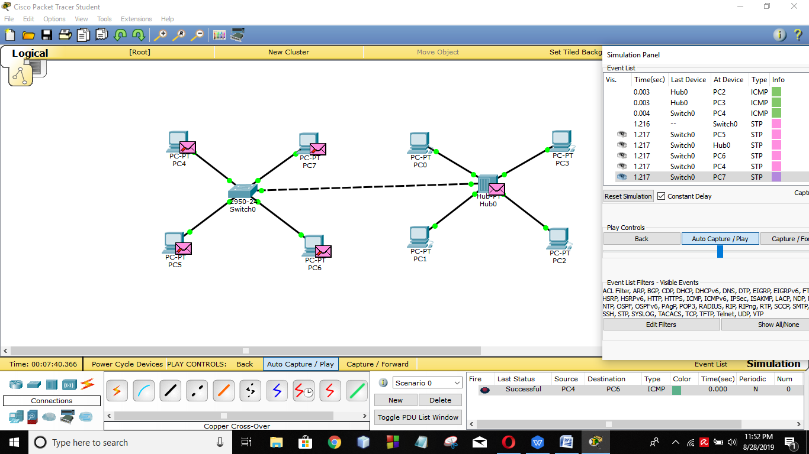

1. **Show the operation of a hub using tracer simulation.**

This screenshot shows the transmission of data between 8 devices using 2 switches.

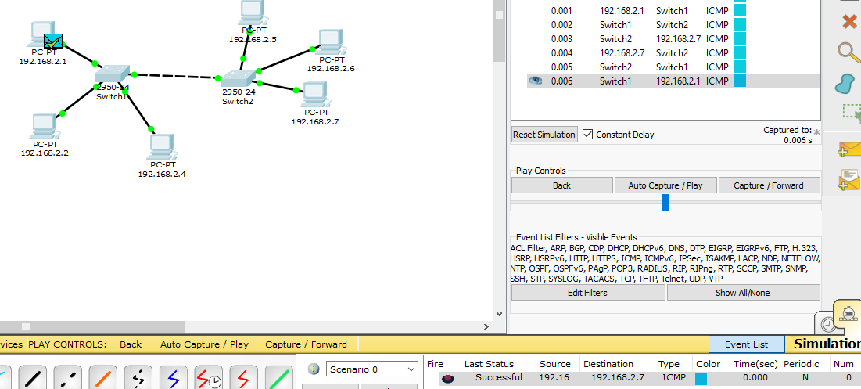

1. **Show the operation of a hub and two switch.**

This screenshot shows the transmission of data between 13 devices using a hub & 2 switches.

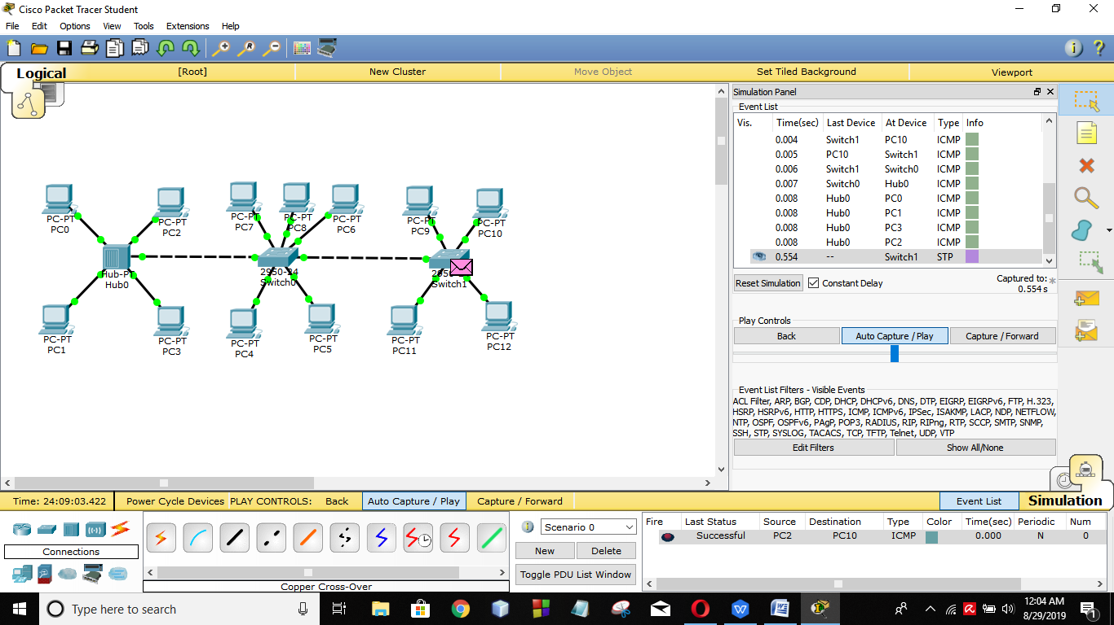

**Discussion :**

A switch is effectively a higher-performance alternative to a hub. People tend to benefit from a switch over a hub if their home network has four or more computers, or if they want to use their home network for applications that generate significant amounts of network traffic, like multiplayer games or heavy music file sharing. Technically speaking, hubs operate using a broadcast model and switches operate using a virtual circuit model. When four computers are connected to a hub, for example, and two of those computers communicate with each other, hubs simply pass through all network traffic to each of the four computers. Switches, on the other hand, are capable of determining the destination of each individual traffic element (such as an Ethernet frame) and selectively forwarding data to the one computer that actually needs it. By generating less network traffic in delivering messages, a switch performs better than a hub on busy networks.